Adrian Cuyugan 2014-91450 Stat 266 Two-Sample Tests
6.9 – The 2000 census statistics for Alabama give the percentage changes in population between 1990 and 2000 for each of the 67 counties. These counties were divided into two mutually independent groups, rural and non-rural, according to population size of less than 25,000 in 2,000 or not. Random samples of nine rural and seven non-rural countries gave the following data on percentage population change.
Use all of the methods of this chapter to test the null hypotheses of equal distributions.
Rural | -21.7 |  | -16.3 |  | -11.3 |  | -10.4 |  | -7.0 |  | -2.0 |  | -1.9 |  | 1.1 | 6.2
Non-Rural |  | -2.4 |  | 9.9 |  | 14.2 |  | 18.4 |  | 20.1 |  | 23.1 |  | 70.4

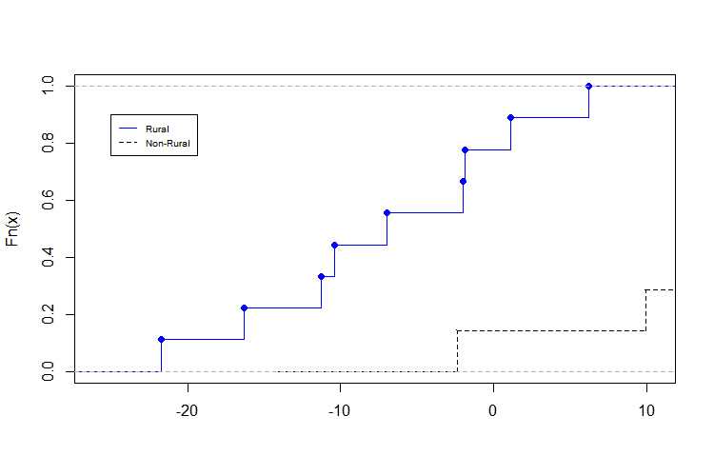
Komolgorov-Smirnov Two-Sample Test
$$x$$Pooled ordered sample from two populations | $$S_{m}(x)$$ECDF of Non-Rural, m = 7 | $$S_{n}\left(x\right)$$  ECDF of Rural, n = 9 | $${S_{m}\left(x\right)-S}_{n}(x)$$ | $${|S_{m}\left(x\right)-S}_{n}\left(x\right)|$$ | R
-21.7 | 0.1111 | 0.0000 | 0.1111 | 0.1111 | 1
-16.3 | 0.2222 | 0.0000 | 0.2222 | 0.2222
-11.3 | 0.3333 | 0.0000 | 0.3333 | 0.3333
-10.4 | 0.4444 | 0.0000 | 0.4444 | 0.4444
-7.0 | 0.5556 | 0.0000 | 0.5556 | 0.5556
-2.4 | 0.5556 | 0.1429 | 0.4127 | 0.4127 | 1
-2.0 | 0.6667 | 0.1429 | 0.5238 | 0.5238 | 1
-1.9 | 0.7778 | 0.1429 | 0.6349 | 0.6349
1.1 | 0.8889 | 0.1429 | 0.7460 | 0.7460
6.2 | 1.0000 | 0.1429 | 0.8571 | 0.8571
9.9 | 1.0000 | 0.2857 | 0.7143 | 0.7143 | 1
14.2 | 1.0000 | 0.4286 | 0.5714 | 0.5714
18.4 | 1.0000 | 0.5714 | 0.4286 | 0.4286
20.1 | 1.0000 | 0.7143 | 0.2857 | 0.2857
23.1 | 1.0000 | 0.8571 | 0.1429 | 0.1429
70.4 | 1.0000 | 1.0000 | 0.0000 | 0.0000
In a combined ordered arrangement of $m+n$ sample observations, $S_{m}(x)$ and $S_{n}(x)$ are the respective proportions of non-rural and rural observations which do not exceed the specific value of $x$. The null and alternative hypotheses are as follows, if the two population distributions are identical:
$H_{0}: F_{Y}\left(x\right)=F_{X}\left(x\right)$ for all $x$ $H_{A}: F_{Y}(x)≠F_{X}(x)$ for some $x$
The K-S two-sample test criterion is the maximum absolute difference between the two empirical distributions: | The significance level is set at $α=0.05$. In Table I, where $m=7$ and $n=9$, the rejection region with it’s exact tail probability: | Since the computed $D_{7,9}=54$, the null hypothesis is rejected, supporting that the two samples do not have identical distributions.
$$\max_{x}{{|S}_{m}(x)-S_{n}(x)|}=0.8571$$ | $$P[63D_{7,9}≥42]=0.034$$ | $$P\left[63D_{7,9}≥54 \right|H_{0}]<0.05$$

Wald-Wolfowitz Runs Test
Just like in the K-S test, the null hypothesis of identical distributions against the two-sided alternative tests are as follows:
$H_{0}: F_{Y}\left(x\right)=F_{X}\left(x\right)$ for all $x$ $H_{A}: F_{Y}(x)≠F_{X}(x)$ for some $x$
The runs statistic, R, is the total number of runs in the combined ordered arrangement of $m X$ and $n Y$, | The significance level is set at $α=0.05$. In Table D, the left tail-probability where $m=7$ and $n=9$, the rejection region with its exact probability is: | Since the computed runs statistic is within the rejection region, the null hypothesis of identical distributions is also rejected like the former test.
$$R=4$$ | $$P[R≤5]=0.035$$ | $$P\left[R≤4 | H_{0} is true\right]<0.05$$

